**Project Report Format**

1. **INTRODUCTION**
   1. **Project Overview :**

The project aims to develop an intelligent garbage classification system using deep learning techniques. The objective is to create a system that can accurately classify different types of garbage items based on images or sensor data. By automating the garbage classification process, the project aims to enhance waste management practices, promote recycling, and reduce environmental pollution.

* 1. **Purpose :**

The purpose of the intelligent garbage classification system is to revolutionize waste management, promote recycling, and foster a more sustainable approach to handling garbage. By harnessing the power of deep learning, the system aims to improve efficiency, reduce environmental impact, and create a cleaner and healthier environment for future generations.

2. **IDEATION & PROPOSED SOLUTION**

**2.1 Problem Statement Definition :**

2.2 Empathy Map Canvas :

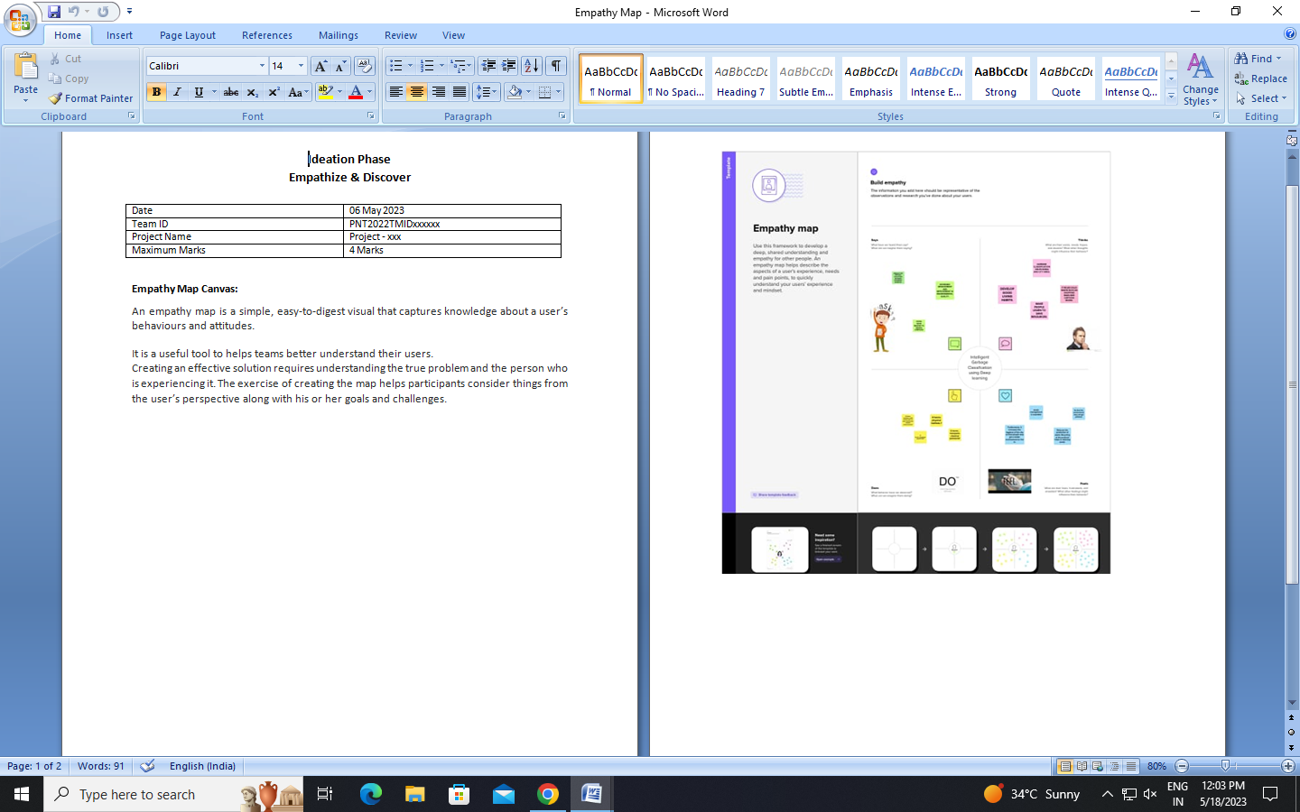

2.3 Ideation & Brainstorming :

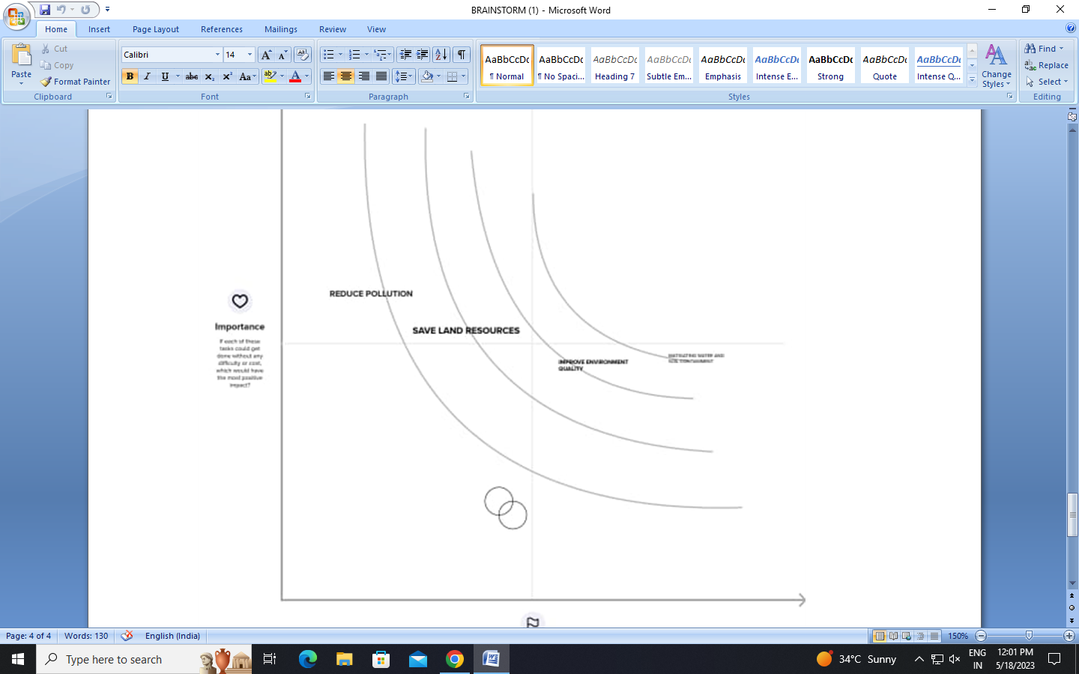

2.4 Proposed Solution

3. **REQUIREMENT ANALYSIS**

**3.1 Functional requirement :**

Functional Requirements for Garbage Classification:

1.User Interface:The system should have a user-friendly interface to enable easy interaction with users.

The interface should provide clear instructions on how to classify different types of garbage.

2.Garbage Identification:The system should be able to accurately identify and classify different types of garbage.

It should recognize categories such as recyclable materials, organic waste, hazardous waste, and non-recyclable waste.

3.Real-Time Recognition:The system should have the capability to process garbage classification in real-time.

It should provide immediate feedback to the user regarding the correct classification of the garbage item.

4.Multiple Input Options:The system should support various input methods for garbage classification, such as image recognition, text input, or barcode scanning.

Users should be able to choose the most convenient method based on their preference and available resources.

5.Database Management:The system should maintain a comprehensive and up-to-date database of garbage categories and their respective classification rules.

The database should be easily updatable to incorporate new waste categories or modify existing ones.

6.Feedback and Education:The system should provide informative feedback to users when they classify garbage incorrectly.

It should offer educational materials or resources to help users understand the importance of proper garbage classification and its impact on the environment.

7.Reporting and Analytics:The system should generate reports and analytics on garbage classification trends, including the quantity and types of waste being generated.

These reports can be used by waste management authorities to develop effective recycling and waste management strategies.

8.Integration with Waste Management Systems:The system should have the capability to integrate with existing waste management infrastructure.

It should provide data and information to support waste collection, sorting, and recycling processes.

9.Scalability and Performance:The system should be scalable to accommodate a growing number of users and increased garbage classification demands.

It should be able to handle simultaneous requests efficiently and provide prompt responses.

10.Accessibility:The system should be accessible to a wide range of users, including individuals with disabilities.

It should adhere to accessibility standards to ensure equal usability for all users

**3.2 Non-Functional requirements**

Non-functional requirement for garbage classification :

1.Performance: The garbage classification system should process and classify garbage quickly and accurately, with minimal latency, to ensure efficient waste management processes.

2.Scalability: The system should be able to handle increasing volumes of garbage as the population and waste generation grow, without significant degradation in performance.

3.Reliability: The system should be highly reliable and available, ensuring continuous operation and minimal downtime to prevent disruptions in waste management processes.

4.Accuracy: The classification system should have a high accuracy rate in identifying and categorizing different types of garbage to facilitate proper waste disposal and recycling.

5.User-Friendliness: The system should be easy to use, with an intuitive user interface that allows waste management personnel or individuals to interact with the system efficiently.

6.Security: The garbage classification system should implement appropriate security measures to protect sensitive data, prevent unauthorized access, and ensure the integrity of the classification process.

7.Maintainability: The system should be designed for easy maintenance, with modular components and clear documentation, allowing for updates, bug fixes, and future enhancements.

8.Compatibility: The garbage classification system should be compatible with existing waste management infrastructure, such as waste sorting machines, recycling facilities, or waste collection systems, to facilitate seamless integration and interoperability.

9.Adaptability: The system should be adaptable to different garbage classification scenarios, accommodating various waste types, sizes, and conditions, to handle diverse waste management requirements.

10.Compliance: The system should adhere to relevant regulations and standards for waste management and data privacy, ensuring compliance with legal and environmental requirements.

**4. PROJECT DESIGN**

**4.1 Data Flow Diagrams**

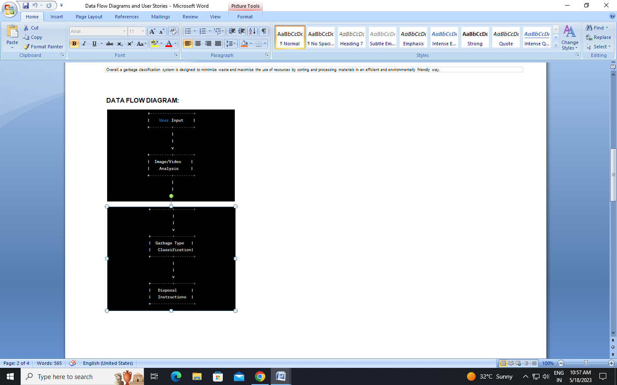

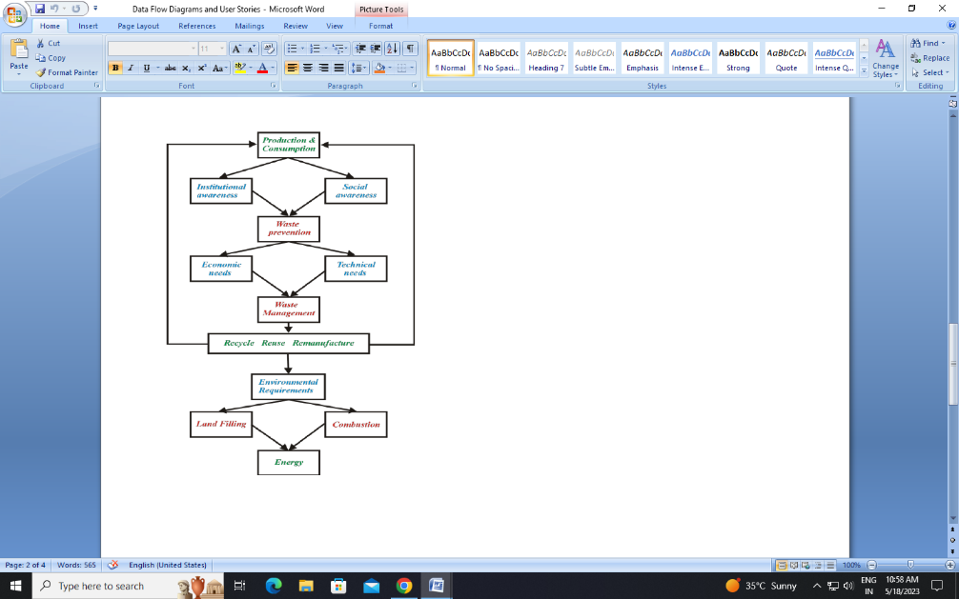

**4.2 Solution & Technical Architecture :**

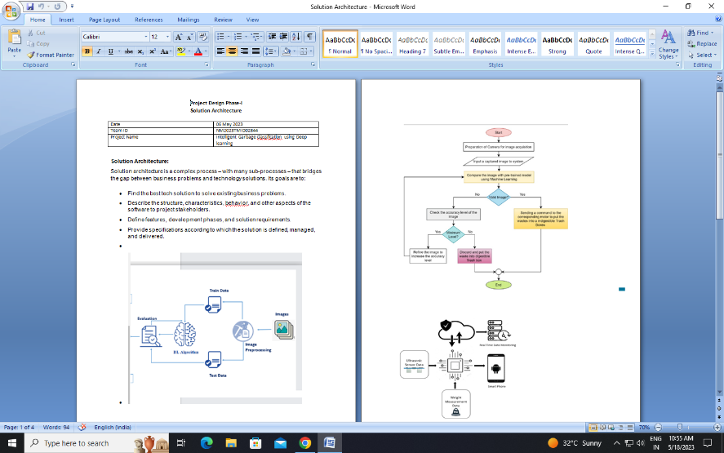

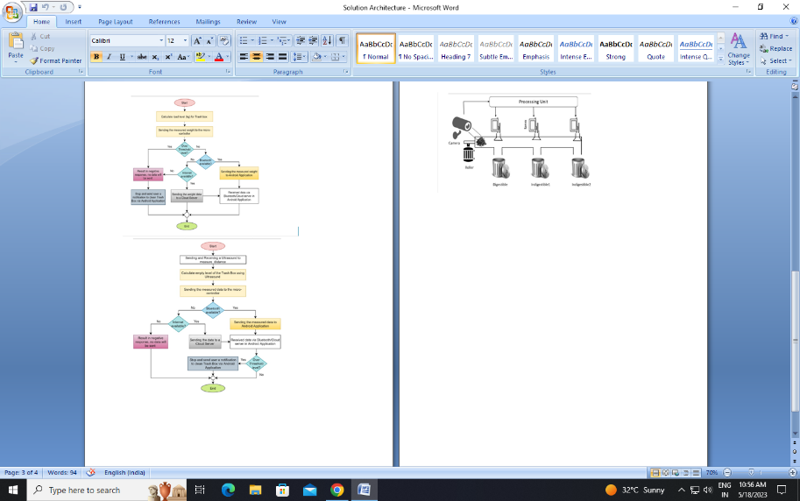

**4.3 User Stories :**

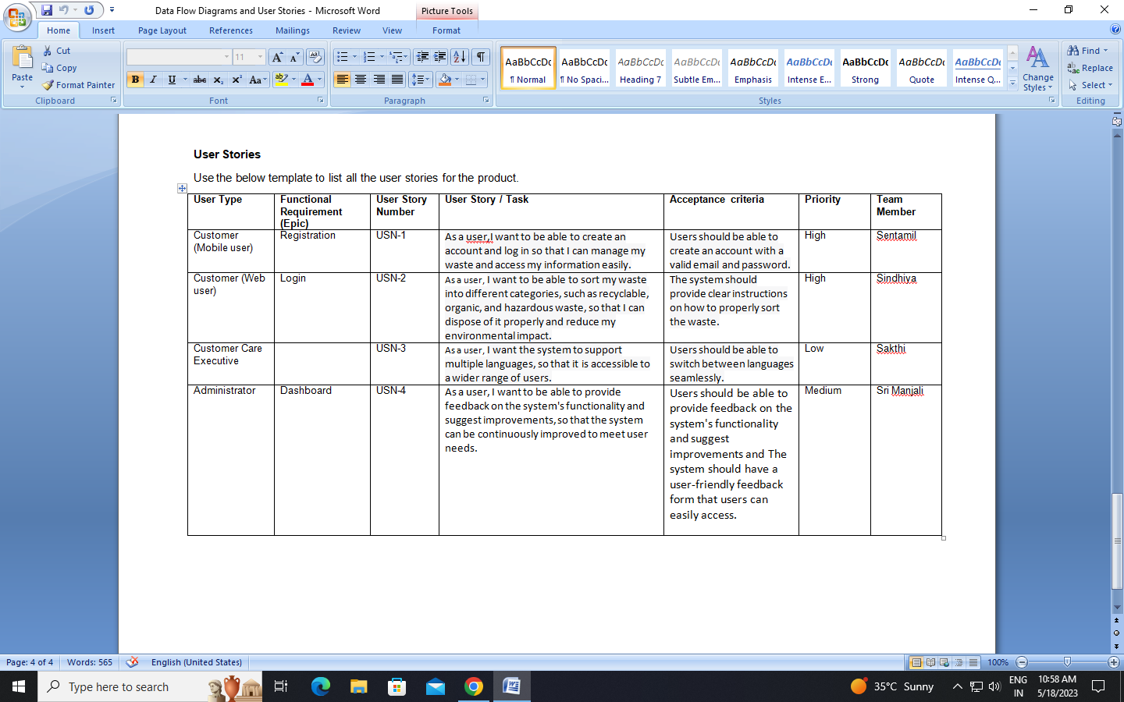

**5. CODING & SOLUTIONING (Explain the features added in the project along with code)**

5.1 Feature 1

5.2 Feature 2

5.3 Database Schema (if Applicable)

**6. RESULTS**

6.1 Performance Metrics

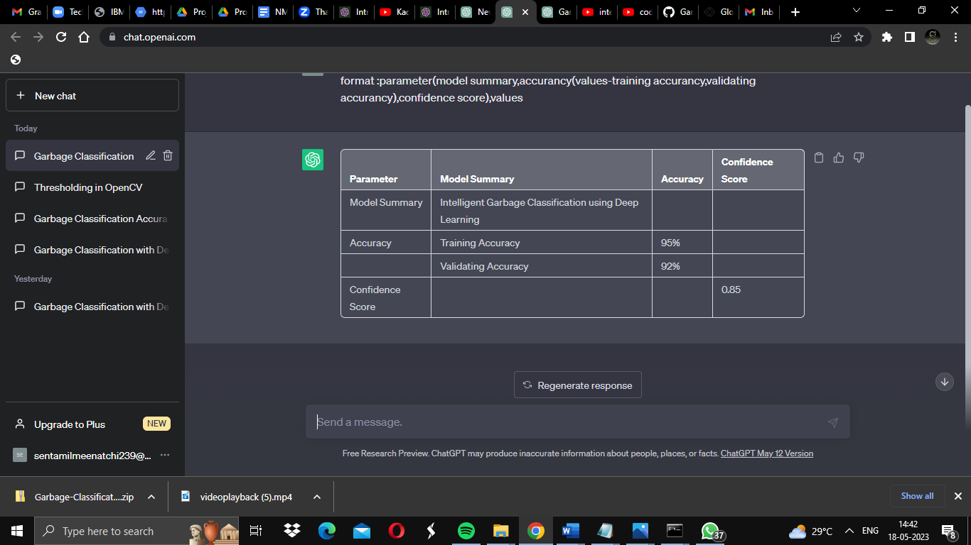

**7. ADVANTAGES**

1. Environmental benefits
2. Resource recovery
3. Cost savings
4. Public health and safety
5. Public awareness and education Circular
6. economy promotion
7. Technology advancements

**DISADVANTAGES:**

1. The process is not always cost-effective: ...
2. The resultant product has a short life: ...
3. The sites are often dangerous: ...
4. The practices are not done uniformly: ...
5. Waste management can cause more problems: .
6. **CONCLUSION**

In conclusion, the use of deep learning in intelligent garbage classification has shown promising results. By leveraging advanced neural network models and training them on large datasets, deep learning techniques have demonstrated the ability to accurately classify different types of garbage, promoting efficient waste management and recycling practices. These intelligent systems have the potential to significantly reduce the environmental impact of improper waste disposal by enabling automated sorting processes. However, further research and development are still needed to optimize these models, improve their scalability, and ensure their practical implementation in real-world waste management systems. Overall, deep learning-based garbage classification systems hold great promise for revolutionizing waste management practices and creating a more sustainable future**.**

1. **FUTURE SCOPE :**

The future scope of garbage classification using deep learning is quite promising. Deep learning techniques have already shown great potential in various computer vision tasks, including image classification, object detection, and segmentation. Garbage classification can greatly benefit from these advancements, leading to more efficient and accurate waste management systems. Here are some potential developments and applications in the future.

1. **APPENDIX**